Tela principal (9000)

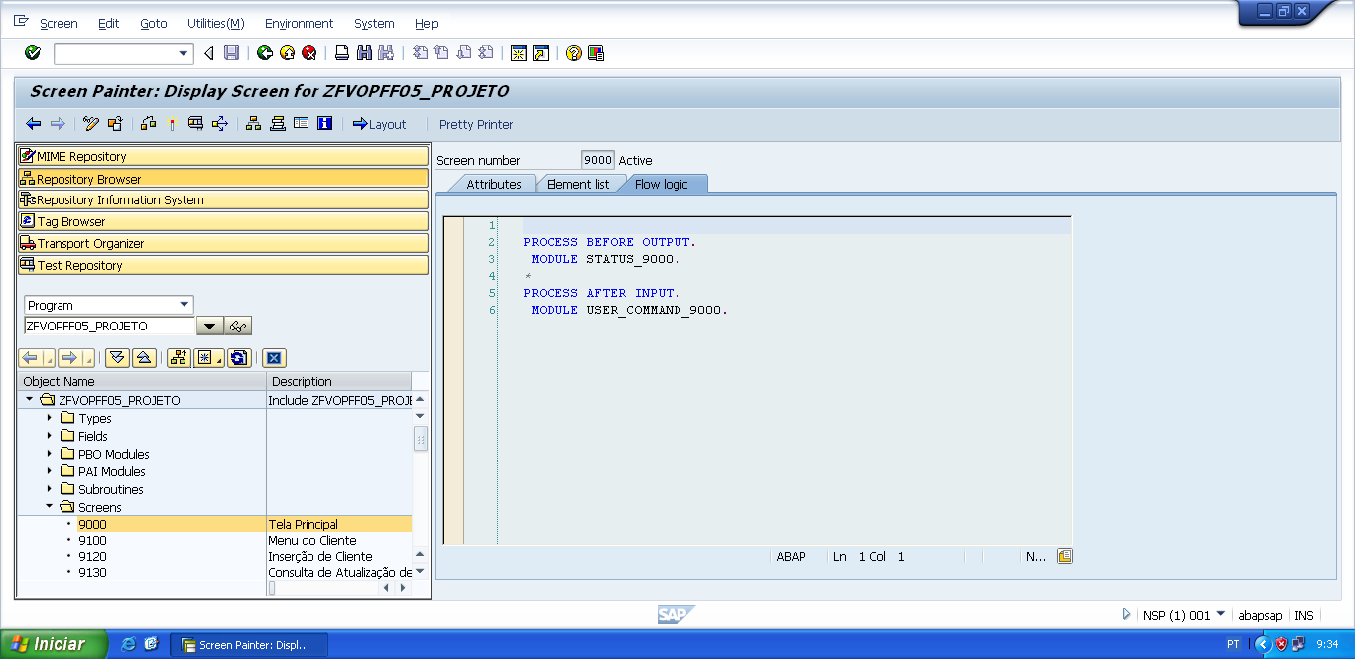

PROCESS BEFORE OUTPUT.  
 MODULE STATUS_9000.

*&---------------------------------------------------------------------*  
*&      Module  STATUS_9000  OUTPUT  
*&---------------------------------------------------------------------*  
*       text  
*----------------------------------------------------------------------*  
MODULE status_9000 OUTPUT.  
  SET PF-STATUS 'STATUS9000'.  
  SET TITLEBAR 'TITULO9000'.  
  
ENDMODULE.                 " STATUS_9000  OUTPUT

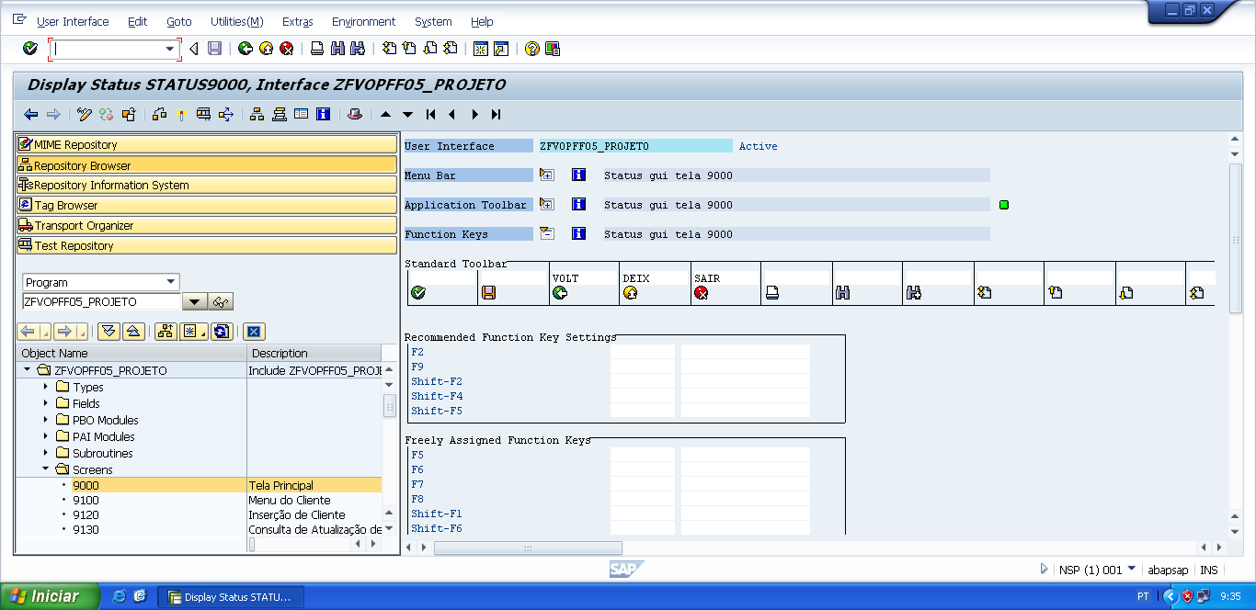

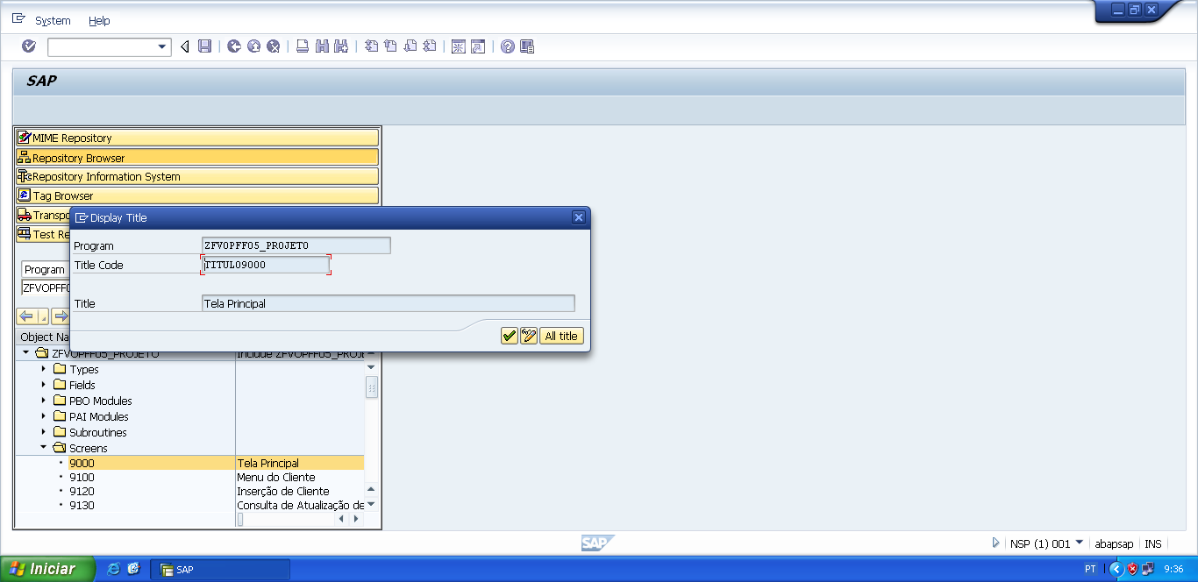

PROCESS AFTER INPUT.  
 MODULE USER_COMMAND_9000.

*&---------------------------------------------------------------------*  
*&      Module  USER_COMMAND_9000  INPUT  
*&---------------------------------------------------------------------*  
*       text  
*----------------------------------------------------------------------*  
MODULE user_command_9000 INPUT.  
  
  v_okcode = sy-ucomm.  
  
  CASE v_okcode.  
    WHEN 'VOLT'.  
      PERFORM f_voltar.  
    WHEN 'DEIX'.  
      PERFORM f_deixar.  
    WHEN 'SAIR'.  
      PERFORM f_sair.  
    WHEN 'CLIE'.  
      PERFORM f_cliente.  
    WHEN 'FORN'.  
      PERFORM f_fornecedor.  
    WHEN 'CARR'.  
      PERFORM f_carro.  
  ENDCASE.  
  
ENDMODULE.                 " USER_COMMAND_9000  INPUT

*&---------------------------------------------------------------------*  
*&      Form  F_VOLTAR  
*&---------------------------------------------------------------------*  
* FORM de voltar, serve para voltar automaticamente para a tela  
*anterior da tela atual.  
*----------------------------------------------------------------------*  
*  -->  p1        text  
*  <--  p2        text  
*----------------------------------------------------------------------*  
FORM f_voltar.  
  
*Volte para á tela 9000 (Tela Principal)  
*ou  
**CALL SCREEN '9000'.**  
  PERFORM f_limpar_variaveis.  
  SET SCREEN 0.  
  LEAVE SCREEN.  
  
  
ENDFORM.                    " F_VOLTAR

*&---------------------------------------------------------------------*  
*&      Form  F_DEIXAR  
*&---------------------------------------------------------------------*  
*       text  
*----------------------------------------------------------------------*  
*  -->  p1        text  
*  <--  p2        text  
*----------------------------------------------------------------------*  
FORM f_deixar .  
  
  LEAVE LIST-PROCESSING.  
  
ENDFORM.

*&---------------------------------------------------------------------*  
*&      Form  F_SAIR  
*&---------------------------------------------------------------------*  
*       text  
*----------------------------------------------------------------------*  
*  -->  p1        text  
*  <--  p2        text  
*----------------------------------------------------------------------*  
FORM f_sair.  
  
  LEAVE LIST-PROCESSING.  
  
ENDFORM.                    " F_SAIR

*&---------------------------------------------------------------------*  
*&      Form  F_CLIENTE  
*&---------------------------------------------------------------------*  
* FORM de indicação de qual tela ele tem que ir se for chamado.  
*----------------------------------------------------------------------*  
*  -->  p1        text  
*  <--  p2        text  
*----------------------------------------------------------------------*  
FORM f_cliente .  
  
  CALL SCREEN '9100'.  
  
ENDFORM.                    " F_CLIENTE

*&---------------------------------------------------------------------*  
*&      Form  F_FORNECEDOR  
*&---------------------------------------------------------------------*  
* FORM de indicação de qual tela ele tem que ir se for chamado.  
*----------------------------------------------------------------------*  
*  -->  p1        text  
*  <--  p2        text  
*----------------------------------------------------------------------*  
FORM f_fornecedor .  
  
  CALL SCREEN '9200'.  
  
ENDFORM.                    " F_FORNECEDOR

*&---------------------------------------------------------------------*  
*&      Form  F_CARRO  
*&---------------------------------------------------------------------*  
* FORM de indicação de qual tela ele tem que ir se for chamado.  
*----------------------------------------------------------------------*  
*  -->  p1        text  
*  <--  p2        text  
*----------------------------------------------------------------------*  
FORM f_carro .  
  
  CALL SCREEN '9300'.  
  
ENDFORM.                    " F_CARRO